Nanjing University of Aeronautics and Astronautics

Experimental Guiding Book

Name of the Curriculum：Vibration Test and Fault Diagnosis of Rotor
Profession (direction): Civil Mechanical and Electrical Engineering

College of Civil Aviation
February 14, 2006

Part One: Experimental Purposes and Requirements
- Learn to testing
Learn and master the mechanical vibration signal of the basic method of measurement, and the actual signal acquisition, analysis and treatment process; Grasp the principle and using method of speed and acceleration sensor ,contact initially with the collection, processing and analysis methods of measured signal.
2. Master the characteristics of graphics
Grasp the meaning of the time waveform, the axis center orbit plot, the frequency spectra, the bode diagram , the polar diagram and the Campbell diagram。Learn some of the characteristics of rotor failure, to make use of relevant information (such as: frequency spectrum, etc.) inferred types of rotor faults.
2.1 Time waveform method
The synchronous vibrations are all periodic vibrations and the basic frequency components of the vibration waveforms mainly include basic frequency component, and some high harmonics functions added by random noise.
The waveform analysis method is to obtain information by observing the characteristics of the vibration waveform.. But the limitation of this method is that when there are many the vibration components, and the waveform is very complication. Therefore it is difficult to obtain the relational diagnosis information by direct observation from the waveform. Actually this method must be combined with frequency spectrum analysis to carry out more effective diagnosis.
2.2 Frequency spectrum analysis method
Frequency spectrum analysis is presently realized by using Fast Fourier Transform (FFT), therefore this method is also called FFT method. The frequency spectrum is a kind of expression form of fault feature. In the diagnosis of rotating machinery, the common frequency spectrums are as follows:
1) Amplitude spectrum and phase spectrum
Suppose X(f) is the Fourier Transform of vibration signal x(t), namely
$$X(f)=F[x(t)]=\int{}x(t)e^{−i2π\text{ft}}\text{dt}$$
Generally, X (f) is a complex number. Let
$X(f)=U(f)+\text{iV}(f)=|X(f)|e^{iφ(f)}$ $|X(f)|=\sqrt{U^{2}(f)+V^{2}(f)}$
$$φ(f)=\text{arctg}\frac{V(f)}{U(f)}$$
Where, $|X(f)|$ is called amplitude spectrum or FFT spectrum, which indicates the distribution situation of the amplitude corresponding to every frequency component in signal along frequency axis; $φ(f)$ is called phase spectrum, which shows the distribution situation of the phases of every frequency component in signal along frequency axis.
The amplitude spectrum can offer the information as follows: The frequency components and harmonics components; the most outstanding amplitudes of the components in the harmonic components, and these amplitudes indicate some relations with faults.
2) Order ratio amplitude spectrum
In synchronous vibration, the basic frequency component of this vibration is equal to the working frequency, namely rotating frequency$f_{r}$. In order to identify the relations of every frequency components and faults easily, the frequency axis often indicates the multiple of the working frequency, but the vertical coordinate indicates amplitude values. This spectrum graph is called order ratio amplitude spectrum. As shown in Figure 5-6.
2.3 The axis center orbit plot
Axis orbit is the track produced by the movement of shaft center relative to bearing house. Flexible rotors all adopt hydrodynamic sliding bearing, and the clearance between bearing and shaft offers condition for the formation of axis orbit. Experiments show axis orbit includes abundant information; therefore, axis orbit is one of the most important means of diagnosing large rotating machinery, such as gas turbine, compressor etc.
The eddy-current sensors perpendicular to each other are commonly installed at the bearing of all large machinery, and they can collect two directions’ displacements signals of shaft relative to bearing. After the signals are processed by charge amplifier and high-pass filter, through amplifying and removing the direct current component of signals, the axis orbit is synthesized.
Axis orbit commonly includes the synthesis results of the waveforms of many frequency components in x—y direction, therefore the axis orbit is very irregular, and it is difficult to obtain the diagnosis information. In order to deal with this problem, according to the principle of frequency spectrum analysis, the main frequency components need be extracted from the frequency spectrum. Supposing the signal is made up of the harmonics as follows:

Where,$f_{r}$ is the basic frequency which is commonly the working frequency or rotating frequency.
2.4 Rotating speed tracking method
Above analysis methods are based on the invariable rotating speed. Therefore, they all belong to steady-state analysis methods. But on many conditions, especially in the process of start-up and stopping, the rotating speed will change continuously, some important diagnosis information can be fully shown. This method is called rotating speed tracking method, which belongs to transient analysis method.
1) Nyquist analysis method
Nyquist analysis method is a polar coordinate method. In the process of rotor startup and stopping, at the every rotating speed, the basic frequency component amplitude of the vibration signal is the module of the polar coordinate, and the benchmark phase angle is argument, so one point on the plane of polar coordinate is obtained. Along with the variety of rotating speed, the polar coordinate graph formed by these points is namely Nyquist plot.
2) Bode diagram
At each rotating speed, the amplitude of basic frequency component and benchmark phase angle are respectively described on the two right-angle logarithm coordinates of rotating speed versus amplitude and rotating speed versus phase. By this way, Bode diagram is obtained.
This diagram is plotted by computer after the vibration signal is filtered by synchronous tracking digital filter. And it is used to forecast the character of system dynamic parameters and system faults.
Supposing the vibration signal is made up of basic frequency component and a number of doubled frequency component as follows: $x(t)=\sum_{k=1}^{n}{a_{k}\text{sin}(2π{\text{kf}}_{r}t+φ_{k})}$.Its basic frequency component is$a_{1}$$\text{sin}(2{πf}_{r}t+ϕ_{k})$, where, $ϕ_{1}$ is called the phase angle of basic frequency component, while the reference phase angle of basic frequency component is defined as the sum of the reference phase angle of rotor and the phase angle of basic frequency component. $θ_{1}=ϕ_{1}+2{πf}_{r}t_{0}=ϕ_{1}+ϕ_{p}$.
Similarly, define the reference phase angle of k-order signal component as follows: $θ_{k}=ϕ_{k}+2π{\text{kf}}_{r}t_{0}=ϕ_{k}+{kϕ}_{p}$.
3) Cascade plot and Campbell diagram
Cascade plot is the 3-D spectrum plot which wraps the power spectra or amplitude spectra of vibration signal along with the rotating speed varying, and it shows the variety of harmonic components along with rotating speed. In Figure, the biases indicate the peak change of every multiple frequency component, but the peaks on vertical line indicate the vibration which has no relation with rotating speed, such as the peaks excited by resonance electrical source.
The diagram is similar to cascade plot. Its horizontal coordinate is rotating speed, and its vertical coordinate is frequency, and the biases are the orders ratio of each multiple frequency component. The amplitudes of components are showed by the size of circle.
3. Improve ability
In accordance with the purpose of the experiment, the basic principles and the results of experimental requirements, select the sensor, measurement software, the location of the sensor layout, measurement selection, and enhance the students’ ability to deal with practical problems, analysis and solving ability.
Part Two: The principle related to the test
1. The principle of vibration test
Rotating machinery is always accompanied by a variety of vibration, because of the unbalanced rotating parts, uneven loads, and the anisotropic of structural stiffness, gap, bad lubrication, support loosening and other factors.
Mechanical vibration is harmful in most cases. It usually reduces the machine performance, damages its normal work, shortens the life, and even causes accidents. Furthermore, mechanical vibration is also accompanied by the noise with same frequency, deteriorating to the environment, and harm to health. On the other hand, the vibration has also been used to achieve useful work, such as transportation, tamping, cleaning, grinding and dehydration. At this time, must select the vibration parameters correctly, and give full play to the performance of the vibrating machinery.
In the modern enterprise management system, mechanical equipments need meet the requirements of low vibration and low noise. In addition to, monitoring, analysis, diagnosis the machine’s running states any time, control the work environment. In order to enhance the anti-vibration performance of mechanical structure, it is necessary for mechanical structure to do vibration analyzing and vibration designing. These are inseparable from the vibration test.
Vibration testing includes two ways: A) Measure the vibration of machineries or structures under working status, (such as vibration displacement, velocity, acceleration, frequency and phase, etc), know the vibration state of tested object, ratings and look for vibration source, take corresponding measures to monitoring, analysis, diagnosis and prediction. B) Measure the forced vibration of mechanical equipments or structures after exerting some stimulate ,in order to impose some kind of incentive structure, measured by the forced vibration, in order to obtain the vibration dynamic parameters or the dynamic performance of the measured object (such as natural frequency, damping, stiffness, frequency response , modal and so on).
Vibration amplitude, frequency and phase are the three basic parameters of vibration, known as the three elements of the vibration.
Amplitude: amplitude is maker of the vibration strength; it could be expressed by peak, RMS and average, etc.
Frequency：Different frequency reflect vibration source of the system. Through spectrum analysis can determine main Frequency composition and the size of amplitude, So we can find vibration source and Take appropriate measures.
Phase: the phase information is very important for Vibration signal. For example, we can use the phase relation to determine resonance point ,measure vibration mode, dynamic balance of rotating parts, Control Active Vibration, noise reduction and so on.. For Complex vibration waveform analysis, Phase of the harmonic relations are an indispensable.
At vibration measurements, we should select reasonable measurement parameters. For example Vibration displacement is important for strength and deformation; Vibration acceleration is directly proportional to the force or load, it is important basis research on dynamic strength fatigue. Vibration velocity determines the level of noise. Velocity determines people’s sensitive degree for mechanical vibration. Velocity is related to energy and power, and decides the size of momentum.
2. Actual signal sampling and analysis principle
Test signal is obtained from the sensor are mostly Analog signals, Before the digital signal processing, general signal should be pretreatment and digital processing, however Digital sensor can be directly connected with the computer through the interface, Digital signal will be sent to the computer(or digital signal processor)to processing .Testing digital signal processing system shows in Figure 1.
Analog Signal
Display Device
Digital
Signal
Analog
Signal

Signal Amplification
A/D Transformation
Computer
D/A Transformation
Control Device
Fig .1 Signal processing

The continuous-time signals are converted to its corresponding digital signal known as the analog-digital conversion (A/D). Otherwise known as the digital-analog conversion (D/A). They are the necessary procedures for digital signal processing. General before the A / D conversion, Analog signals will be pretreatment by the anti-aliasing filter becomes into band-limited signals, and then through A / D converter as a digital signal. Finally send it into the digital signal processing instrument or digital computer to processing. If necessary, it is needs for D / A converters to convert digital signals into analog signals，in order to drive the computer peripheral actuator or recorder etc.
A / D conversion Including sampling , quantization coding , working principle shows in Figure 2.

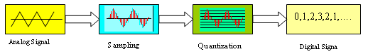
Fig.2 Signal A / D conversion process

3. Theory of spectrum analysis
Signal spectrum analysis can be divided into the amplitude spectrum, phase spectrum, power spectrum, and logarithmic spectrum and so on. Fourier transform is commonly used as a tool for signals spectrum analysis. Some is decomposed into infinite number of a certain relationship sinusoidal signal by Fourier transform .Through the sinusoidal signal to study the complex signal’s frequency components and amplitude.
Signal spectrum analysis use Fourier transform to change time-domain signal x(t) into Frequency domain signal X(w), which helps people from another angle to know the characteristics of signal. The Fourier transform of the Time-domain signal x (t) is: $X(w)=\int{x(t)e^{−\text{jwt}}}\text{dt}$. X (w) express the frequency domain signal, x (t) express the time-domain signal, w express angular frequency.
4. Sensor principle
4.1 Eddy current displacement sensor working principle
Eddy current displacement sensor working principle shows in Figure 3:
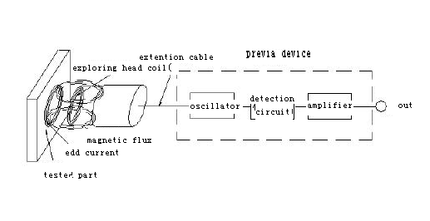
Fig.3: The working principle of eddy current displacement sensor
It can static and dynamic non-contact, high linearity, high-resolution measurement distance between probe and measured metal conductor. It is a non-contact measurement of linear instrument. Eddy current displacement sensor can measured accurately static and dynamic changes between probe compo and measured metal conductor probe (extension cable), preamplifier, measured metal conductor sition the system. High frequency oscillation current of preamplifier flows into the probe through the extension cable. At the head of the probe generate alternating magnetic field. If at the effective boundary of the alternating magnetic field is no metal material. And then the magnetic field energy will be lost. On the contrary, in the metal surface generate current. Electromagnetic calls eddy current. At the same time the electric eddy current field will generate alternating magnetic field which has a opposite direction with the head coil. Because it’s counterproductive, it will make amplitude and phase of the head coil’s high-frequency change. This change is related to permeability, conductivity, geometry, geometry size, current frequency, and distance between probe and measured metal conductor. Usually assumed that the metal conductor material uniform and have linear performance. The physical properties of the coil and the metal conductor system can be described by conductivity б, Permeability ξ, Size factor τ, between probe and measured metal conductor D, Current intensity and Frequency ω. The coil impedance Characteristics can be used to express by function Z=F (τ, ξ, б, D, I, ω). Usually we can control parameters τ, ξ, б, I, ω at the same within a certain range. Characteristic impedance of the coil becomes a single-valued function of the distance D. Although the entire function is a non-linear function, the function characteristic is curve "S" ，However, it can select a section of approximation linear. And then preamplifier processes the signal. Changes the coil impedance Z which distance changes D between probe and measured metal conductor the into voltage or current, The size of the output signal Change with distance D between probe and measured metal conductor. Eddy current sensor is based on this principle to measure displacement and vibration.
There is neither need to change the shape of the, nor affect the, therefore, Eddy Current Testing is a non-destructive test to assess sample’s performance and found pieces of the specimen.
Eddy current testing is only applicable to material which can produce eddy current, meanwhile, because of eddy current is generated by electromagnetic. There is no need to contact coil with sample, or to fill mixture between sample and coil, it is easy to automate testing. Eddy current inspection method has high speed and efficiency on the tube, rod, wire surface defects,
Metal samples Physics and technology parameters affect eddy current and reaction magnetic field, so eddy current testing is a multi-purpose testing method. However, because it is sensitive to testing parameters, it would impact test results.
If Right to connect power and computer, eddy current displacement sensor are installed on rotor test rig (X, Y at90-degree), and connect with output cable,signal flow preamplifier and data acquisition instrument into the computer.

4.2 Principle of reflective photoelectric speed sensor
Principle of reflective photoelectric speed sensor is shown in figure 4. It mainly consists of rotating parts for tested, reflective film (or reflective paper) and reflective photoelectric sensor. In the circumstances of accurate positioning, it will obtain a better measurement results when installing multiple reflective films (or reflective papers) on the symmetric positions of the measured components.
In this experiment, there is only one piece of reflective film installing on the tested part because of the near-distance and low test requirement. Therefore, the output of photoelectric sensor will be hopping again when the reflective film of rotating components passing the photoelectric sensor. So, know the rotating speed n through measuring the hopping frequency f.
$$n=f$$
If we install a number of reflective films (or reflective papers) on the symmetric positions of the measured components, then, n = f / N. Where, N is the number of reflective film or reflective papers.
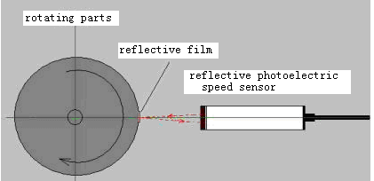
Fig. 4: Principle of reflective photoelectric speed sensor

4.3 Principle of piezoelectric acceleration sensor
Piezoelectric sensor’s mechanical model can be simplified as a single freedom quality - spring system. According to the principle of piezoelectric effect, as shown in figure 5, the crystal will have a charge after being forced vibration force. The charge is directly proportional to the force. This is the working principle of piezoelectric sensors converting mechanic and electric.
Piezoelectric acceleration sensor has been widely used in the field of vibration test, measuring vibration parameters in a variety of environment.

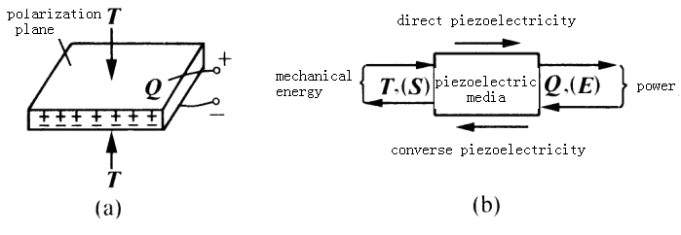
Fig.5: Piezoelectric Effect

Part Three: Experiment Instrument and Analysis Software
1. Type of Zt-3 Rotor Experiment Instrument
The rotor experiment instrument is a comprehensive experimental platform, which is composed by motor, rotor and speed control system, and on which the sensors that can measure the machine parameters of the vibration, displacement, rotate speed and acceleration can be flexibly installed, So that the instrument can carry through the comprehensive engineering test. The rotor experiment instrument is shown as fig.6.
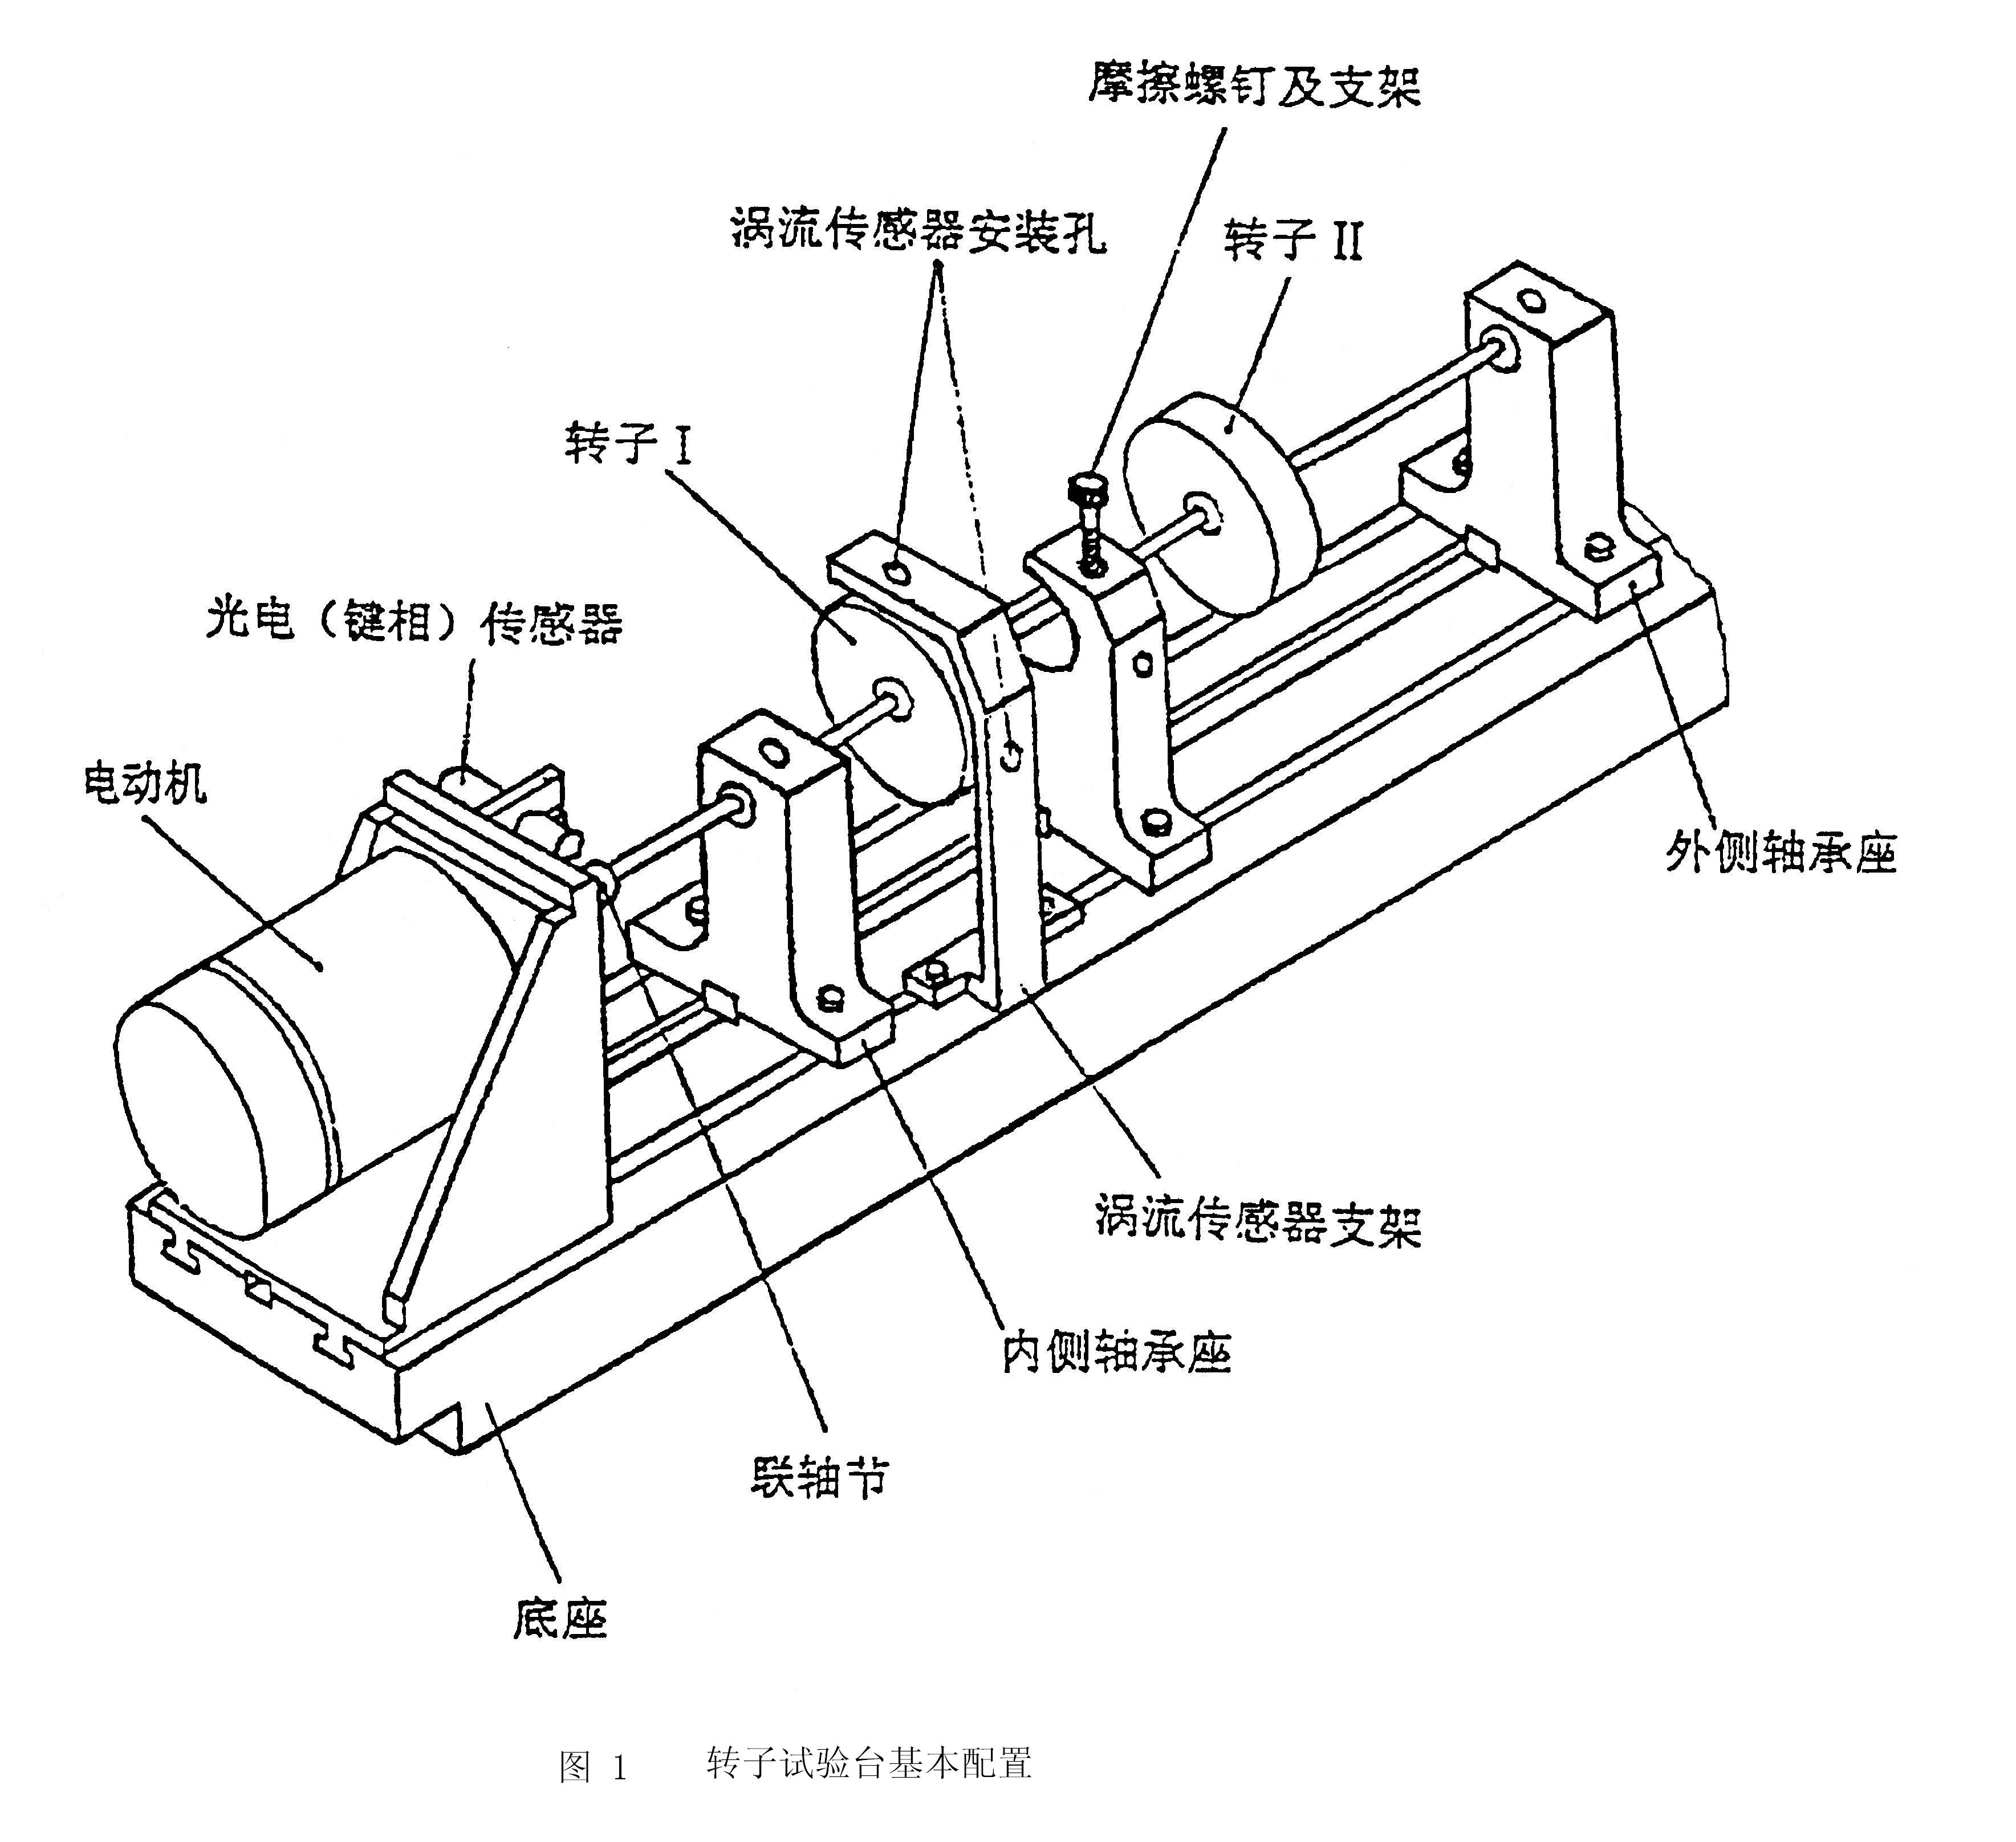
rubbing-impact screw

rotorⅡ
mounting hole
of eddy current sensor
rotorⅠ
photoelectric sensor

motor
base
coupling
inside bearing seat

outside bearing seat

support of eddy current sensor

Fig.6 Rotor Experiment Instrument

We can simulate the running state of rotating machine by changing the rotate speed of rotor, shafting stiffness, unbalance value, the state of bearing the type of coupling. The vibration characteristic can be observed noted by software.
2. 1Software Introduction
DHDAS system software of signal test and analysis is available for several equipments of a variety of models in our company, which can control any one or a combination of two or more equipments, the user can select channel type and mix them freely according to their demands, The number of measured channels can be up to 128, with strong flexibility. Sampling frequency of the system range 10 Hz to 128 KHz, and it can meet the measurement needs of vast majority types.
Common test items include the following components:
1) Hardware (computer, data acquisition box, wires, sensors, etc.);
2) Software (testing software, operating systems);
3) Testers (user);
4) Testing process (which is designed by the user and to achieve some testing purposes).
2.2 The main functions of the software
DHDAS software has rich functions of testing and anglicizing, and is easy to operate and use. Experimental projects which can be carried out include:
1) Measuring the critical speed of rotor.
2) Measuring the bearing block and body vibration units.
3) Oil whirl and oil whip of sliding bearing.
4) radial vibration and axial displacement of non-contact measurement axis.
5) fundamental frequency, multiple frequency and half frequency of rotor vibration.
6) Three-dimensional colored spectrum matrix analysis of rotor start-stop machine.
7) Analysis of purifying rotor axis orbit.
8) time domain and spectrum analysis of rotor vibration signal.

Part Four: Experiment Contents
Experiment One: Rotor imbalance Experiment
1. Experimental Purpose
1.1Realizing the mechanisms of rotor imbalance
Rotor imbalance is the common cause of the failure of all kinds of rotating machinery. Rotor imbalance includes mass eccentricity of rotor system and defect of rotor parts. Mass eccentricity of rotor is caused by manufacture error, assembly error, uneven material etc. The defect of rotor parts is affected by fatigue force, corrosion and wear, the local defects and peelings of rotor parts happen so that the new rotor imbalance occurs.
1.2 Analyzing Vibration characteristics of rotor imbalance
Frequency characteristic: The excitation frequency of vibration is single rotating frequency (namely the working frequency), and does not include other multiple frequency components.
Phase characteristic: The phase is stable at the working frequency.
Dynamic characteristic of rotating speed tracking: When rotor starts up, vibration amplitude increases along with the increase of rotating speed. At critical rotating speed, the biggest peak value (resonance) occurs. When rotating speed exceeds critical rotating speed, the vibration amplitude gradually decreases and tends to a certain value namely eccentricity value.
2. Experimental Principle
The excitation frequency of unbalance vibration is single rotating frequency (namely the working frequency), and does not include other multiple frequency components. The experiment results maybe have the multiple rotating frequency, which caused by the error that can’t be avoid.
The axis orbit under the unbalance is rotundity in theory, because oil film stiffness is different between the X and Y direction, as well as others influencing factors, the orbit is an ellipse.
3. Experimental Contents and Steps
1) The Setting Method of Rotor Imbalance Experiment
In order to easy to realize the rotor dynamic balancing, we process circumferential balance grooves in flanks of rotor. M2 standard screw and nut are used as weight balances, each of which is weighing about 0.3 grams.
3 or 5 screws are added in the groove at the side of the rotor, and then they need to be tightened. Screws should be concentrated so that the rotor imbalance happens.
2) To start the experiment equipment, to run the dynamic analysis software
4. Experimental Equipment
ZT-3 rotor vibration simulation test rig
Rotating Machinery analysis software - DHDAS Signal Test Analysis System
5. Requirements for Experimental Report
See in Part Five, "Experimental grouping and requirements.
Experiment Two: Rotor Misalignment Experiment
1. Experimental Purpose
1.1Realizing the mechanisms of rotor misalignment
The rotors of unit are joined by shaft coupling to compose shaft system for transferring movement and torque. Because of connecting error, the deformation under weight load and uneven sedimentation of machine foundation, etc, when machine works, the axis line parallel displacement, the axis line angle displacement or their integrated displacement between axis lines of rotors are generated, that are called rotor misalignment. 60 percent of the faults of rotor system are caused by rotor misalignment. When the rotor with the fault of misalignment rotates, a series of dynamic effects which are harmful to equipments will happen. For example, the deflection of shaft coupling, early damage of bearing and oil-film instability etc can be caused. The fault of rotor misalignment is one of the common faults of rotating machinery, and misalignment can be divided into: parallel misalignment, angle misalignment and their combination.
Because of the rotor misalignment, in the shaft system, not only the mutual position between rotor journal and bearings and the working condition of bearings will be changed, but also the natural frequency of bearing will be decreased. The additional force acting on rotor and its supports is the main cause for abnormal vibration of the rotor and the early damage of bearing.
The causes of rotor misalignment: Bad installation of rotor and supports; the deformation of bearing supports caused by uneven expansion and the sedimentation of foundation.
1.2 Analyzing Vibration characteristics of rotor misalignment
Rotor vibration characteristics of misalignment:
1) Shape characteristic of vibration: The parallel misalignment mainly causes the radial vibration of rotor, but angle alignment causes not only radial vibration, but also axial vibration. Actually, the misalignment which often happens is mostly combination misalignment; therefore, axial vibration is usually a symptom of the rotor system with the fault of misalignment.
2) Frequency characteristic of vibration: Rotor misalignment is equal to inputting some exciting force at the end of shaft coupling. The results of theories and experiments show: for rigid coupling and gear coupling, their radial exciting frequencies include rotating frequency, twice or 4-multiple or high even-multiple rotating frequency.
2. Experimental Principle
2.1 The high order harmonics for rotor misalignment vibration
Rotor misalignment is equivalent to a certain incentive at the end of sleeve. Theoretical and experimental results show that there will be radial excitation frequency accompanying with high frequency even as to the rigid shaft and a gear shaft connection, which verifies the mechanism of misalignment failure.
2.2 Diagrams of axis orbit
The axis orbit caused by different extents misalignments show ellipse, banana-shaped or “8” shape; the axis orbit caused by oil-film whirl is inside “8” shape.
3. Experimental Contents and Steps
3.1 The Setting Method of Rotor Misalignment Experiment
Screw off the screws from the fixation apparatus and add one or two gasket under the fixation apparatus, and then tighten them, which will cause misalignment.
3.2 To start the experiment equipment, to run the dynamic analysis software
4. Experimental Equipment
ZT-3 rotor vibration simulation test rig
Rotating Machinery analysis software - DHDAS Signal Test Analysis System
5. Requirements for Experimental Report
See in Part Five, "Experimental grouping and requirements.

Experiment Three: Rotor-stator Rubbing Experiment
1. Experimental Purpose
1.1 Understanding the mechanism of rotor-stator rubbing faults
In the high speed rotating machinery, in order to improve the machine efficiency, the seal clearance and bearing clearance are usually decreased, but small clearance causes not only fluid dynamic force exciting vibration, but also the rubbing between rotor and stator. Further, dry friction and half dry friction in bearing can also happen, and this kind of friction is sometimes inconspicuous, and the obvious faults will not happen, it can not be found until the machine is not disassembled. The rotor-stator rubbing happens in the following cases: The one is the radial friction caused by the contact between outside edge of rotor or journal and stator during the whirl process of rotor; the other is axial friction caused by the contact between rotor and stator in axial direction.
1.2 Mastering the characteristics of rotor-stator rubbing faults
Friction vibration is nonlinear vibration. The vibration frequencies caused by local friction include some high order harmonics, such as 2×、3×…. In the frequency spectra, the sub-harmonic components of (1/n)× appear, for serious friction, n=2; for slight friction, n=2,3,4…, and the range of sub-harmonic lies on the balance condition of rotor. In rotor system with enough high damping, it is possible that the sub-harmonic vibration does not completely happen.

2. Experimental Principle
2.1 The high order harmonics for friction vibration
In the case of the rubbing just happening, because of rotor imbalance or rotor bending, the amplitude value of rotor’s basic frequency is very great. In high order harmonics, 2 and 3 multiple frequency harmonics are commonly not too great, and the amplitude value of twice frequency harmonic is greater than one of 3-multiple frequency harmonic. Along with the increasing of friction contact arc, because of the additional support effect of friction, the amplitude value of basic frequency decreases, and the amplitude values of 2 and 3 multiple frequency harmonics increase because of additional nonlinear action.
2.2 Diagrams of axis orbit
Because of major area dry friction between journal and stationary components, great friction will be produced between the rotor and stator, so the rotor may be in a completely unstable state, whose axis orbit will be chaotic.

3. Experimental Contents and Steps
3.1 Put the inner and outer bearing seat as far as possible;
3.2 Install a long axis about 500 mm in test-bed, in which only one rotor is installed (in order to reduce the first-order critical speed), friction screw is installed in about 8 mm from the rotor;
3.3 The supporter for X and Y directions sensors is placed at the other side of the rotor, which should be the as close as possible to rotor;
3.4 Keep the friction screw not contact with the shaft and start the rotor at the first-order critical speed, and then record the data;
3.5 Adjust the rotor speed to 2.5 times of the first-order critical speed, and observe the axis orbit on the oscilloscope;
3.6：Carefully screw down friction screw until contact with the shaft;
3.8 Regulate speed more than three times of the first-order critical speed until three still highlights appearing on diagrams of axis orbit.

4. Experimental Equipment
ZT-3 rotor vibration simulation test rig
Rotating Machinery analysis software - DHDAS Signal Test Analysis System

5. Requirements for Experimental Report
See in Part Five, "Experimental grouping and requirements.
Experiment Four: Oil-film whirl and oscillation Experiment
1. Experimental Principle
1.1 The order spectrum for oil-film whirl
The main feature of order spectrum is that there is a peak in the harmonic spectrum at half the frequency, with oil-film whirl, the frequency of whirl is increasing as increasing speed ,and the amplitude of half-frequency harmonic in frequency spectrum diagram is also increasing. At the same time the high-order harmonics may be generated. If the rotor speed is up to 2 times of the first critical speed, a self-excited vibration will be generated, and the vibration will be very intense, the amplitude of which will increase suddenly, and the amplitude of half-frequency harmonic will increase to more than that of fundamental frequency in frequency spectrum diagram.
1.2 Axis orbit for oil-film whirl
Axis orbit for oil-film whirl is comparatively stable double-oval superimposed by the fundamental frequency and half-frequency, and the phase is also of stability, If the rotor speed is up to 2 times of the first critical speed, a self-excited vibration will be generated, and the vibration will be very intense, the amplitude of which will increase suddenly, axis orbit will suddenly become irregular curve.
2. Experimental Purpose
2.1 Understanding the mechanism of oil-film whirl and oscillation
The oil-film oscillation is a self-excited vibration which happens when the whirl frequency of rotor is close to natural frequency of rotor. When the oil-film whirl occurs, the vibration amplitude greatly increases, and the bearing and rotor can be seriously damaged but the abnormal vibration at half of the working frequency and close to natural frequency of rotor is uncertainly caused by oil-film oscillation, and the oil-film oscillation is not the same as the rotor vibration passing the critical rotating speed.
2.2 Mastering the characteristics of oil-film whirl and oscillation
1) Oil-film whirl is the self-excited vibration, and its vibration has nonlinear vibration characteristics. The characteristic frequency includes the combination frequency of basic frequency and whirl frequency, and its happening and disappearance are sudden.
2) Before oil-film oscillation happens, the oil-film whirl phenomenon can commonly occur. When oil-film resonance happens, the frequency of journal whirl is the first order natural frequency of rotor.
3) After oil-film oscillation happens, if the rotating speed is continuously increased, the vibration amplitude doe snot decrease.
3. Experimental Contents and Steps
3.1 whirl
Forced vibration for rotor may occur with the imbalance force and other external forces, and a strong excitation factors may be produced in the internal of rotor-bearing system. Under certain conditions, if the rotor supported by the radial sliding bearing rotates with the oil-film force, whirl will be happening, which is known as the film self-excited whirl.
The following components are needed in order to verify the whirl: the shaft (500mm) film with shaft shoulders, bearing supporters equipped with sliding bearing sleeve, valve oil cup and the oil box.
Experimental steps are as follows:
1) Remove the second span rotor, leaving only the first span rotor and the bearing supporter in the second span rotor;
2) Set the rotor in the whirl shaft, which should be inserted within the bearing supporter in the second span rotor and connected tightly with coupling;
3) install bearing supporter to make the with shaft shoulder of whirl shaft into the bearing supporter and at the same time adjust the axial distance between bearing supporter and the shaft to ensure that there is 1 ~ 2 mm gap, and then simultaneously compact;
4) fit up valve oil cup and the oil box;
5) adjust the location in shaft for the rotor, which should be solid tightened away from bearing supporter about 2 / 3;
6) Without friction, pre-load and imbalance, check bending axis; at low speed, radial Beat Volume should be not more than 0.03mm. Whirl at shaft bearings should rotate freely, without significant block;
7）Place the supporter for X and Y directions sensors at the other side of the rotor, which should be the as close as possible to rotor;
8) The output signal lines of pre-amplifier are connected with vibration meter, the signals from which output to the x, y-axis of oscilloscope, and the signals from the phase sensor t output to the Z axis of oscilloscope;
9) open the oil flow valve until the oil drip from the bearings, start test-bed, gradually increase speed, at about 3000 ~ 4000rpm eddy happens. if eddy does not happen immediately, use the nylon pre-load stick to gently lift shaft end.
3.2 Oil-film oscillation
Whirl speed of the rotor is essentially half of the rotor speed, which is known as the semi-whirl. If the whirl happens, no matter the size of the amplitude, the rotor will be out of stability, that is, the so-called rotor instability. Under certain conditions, the rotor has been unstable, but the journal may be of eddy only at a small scope, that is, the amplitude of eddy is very small; it is likely to remain stable as to running machine. However, as the rotor speed increasing, the eddy will gradually increase. The most serious cases, if the rotor speed is relatively high, close to or more than twice of the first-order critical speed, so that resonance oscillation happens. At this time half speed whirl will become very serious, which is known as Oil-film oscillation.
With the limits of the experimental critical speed, we can increase the disc rotor system to reduce the first-order critical speed to below 4000rpm in order to observe oscillation phenomenon at about 9000rpm.Do as the requirement above. From the x, y-axis input of oscilloscope, we can see the changes of radial position at the starting moment.
4. Experimental Equipment
ZT-3 rotor vibration simulation test rig
Rotating Machinery analysis software - DHDAS Signal Test Analysis System
5. Requirements for Experimental Report
See in Part Five, "Experimental grouping and requirements.

Part Five: Experimental grouping and Requirements
1. Experimental grouping
The monitor should distribute 5 people as a group and select the head of group.
2. Experimental Requirements
(1)Each group needs to do five experiments, including the imbalance, misalignment, rotor rubbing, oil film whirl, the rotor speeding up and down experiments.
(2)After the experiment every student must hand in a test report, in which you need to indicate the name, number and the other members including the head in your group.
(3) Each Student is responsible for one experiment recording.
3. Report Requirements
(1) In the experimental report, some corresponding problems are needed to answer in part seven of the experimental guidance book.
(2)Reporting format can be seen in part seven of the experimental guidance book.

Experimental Report
Studient Number： Name： Experimental Date： Score： Group Leader：________ Group Members ____________
1.Experimental record(add another paper for graphics, quote graph number and marked in the table)
（1）rotor unbalance、rotor misalignment、rubbing、oil whirl
speed：________________

graphic  Experimental | time-domain waveform | chart of axes track | spectrum graph
experiment 1
rotor unbalance
experiment 2
rotor misalignment
experiment3
rubbing
experiment 4
oil whirl

2．Question
（1）Analysis characteristics of the experimental graphic.
（2）Vibration of the three elements and their meaning.
（3）Working principle for displacement sensor, speed sensor, acceleration sensor .

